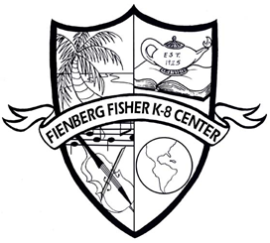

The mission of Fienberg-Fisher K-8 Center, in partnership with our families and diverse community, is to develop healthy, civic minded, innovative individuals. It is our goal to empower students to reach their maximum potential and become caring, reflective, life-long learners with a balanced international perspective and a sense of social responsibility.